


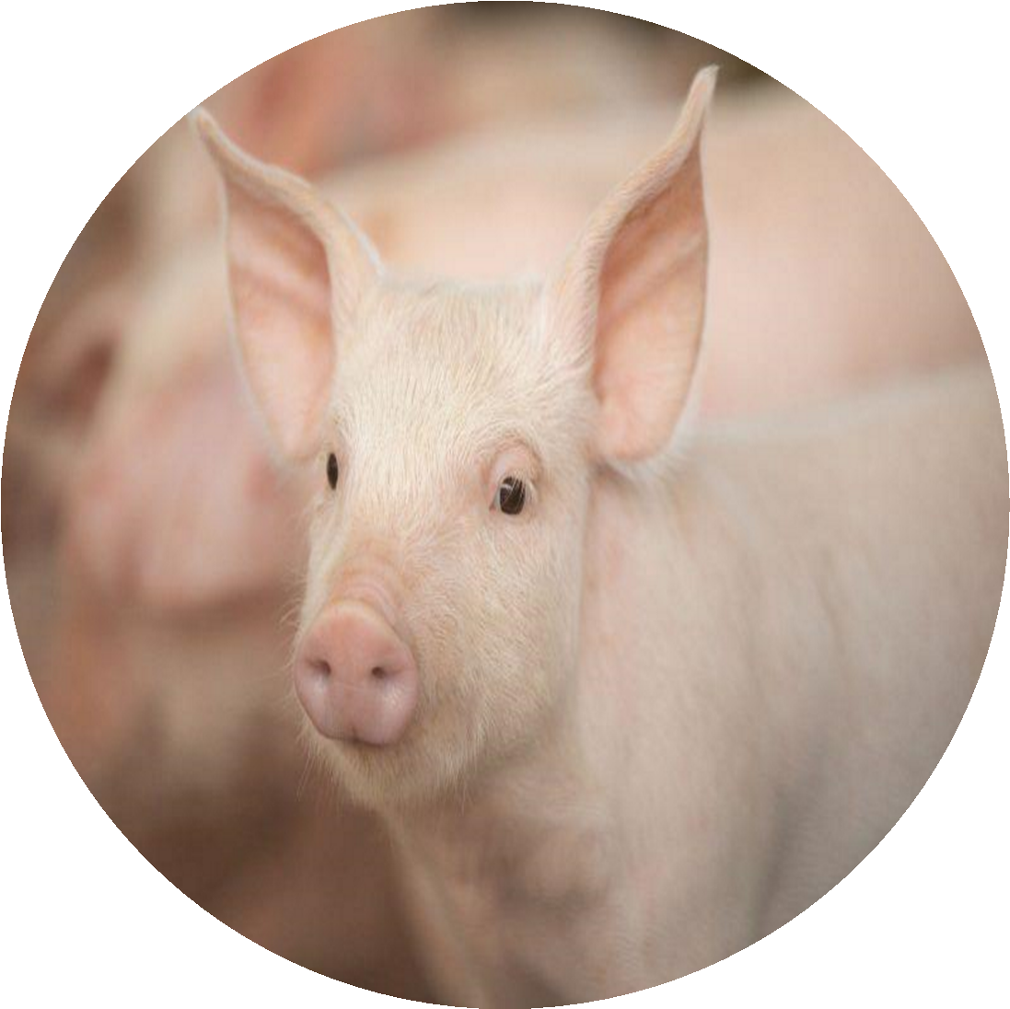
HAPITEC INVESTMENT
LIMITED

WE?

…..WHO ARE
1.0 EXECUTIVE SUMMARY..............................................................................................
2.0 MISSION STATEMENT................................................................................................
2.1 VISION ............................................................................................................................
2.1 OBJECTIVES ..................................................................................................................
3.0 DESCRIBING THE SERVICE .......................................................................................
3.1 Core Values......................................................................................................................
3.2 Features ...........................................................................................................................
4.0 BUSINESS AND INDUSTRY PROFILE.......................................................................
5.0 MARKETING STRATEGY............................................................................................
6.0 SWOT ANALYSIS.........................................................................................................
6.1 STRENGTHS..................................................................................................................
6.2 WEAKNESSES ..............................................................................................................
6.3 OPPORTUNITIES...........................................................................................................
6.4 THREATS........................................................................................................................

Executive Summary

Hapitec Investments Limited is a dynamic Company based in Copperbelt, Zambia, specializing in piggery and various forms of animal husbandry. Our mission is to deliver top-notch, high-quality pigs to local meat processors, butcheries, and corporate organizations, ensuring value for money and unmatched customer satisfaction.
Founded by Mr. Happy Mulobeka, who serves as the Chief Executive Officer, and **Miss Prudence Kambafwile, the company director, Hapitec Investments Limited operates under the robust management principles of Total Quality Management (TQM) and Continuous Improvement (Kaizen). We are committed to exceeding our customers' needs through continuous enhancements in quality and service.

Mr. Mulobeka brings extensive expertise in Business Administration, providing strategic leadership in planning, organizing, directing, and controlling company operations. He collaborates closely with key stakeholders, including customers, employees, and management, to drive decision-making and ensure alignment with our strategic goals. Miss Kambafwile, a seasoned entrepreneur and qualified Registered Nurse, complements this leadership with her hands-on experience and vision, working synergistically with a team of qualified piggery workers to achieve our business objectives.

In addition to the aforementioned core piggery operations, Hapitec Investments has diversified into construction services and supply. This expansion aims to address the growing demand in Zambia's infrastructure and supply sectors, offering comprehensive solutions to businesses and industries across the region. With a steadfast commitment to quality and innovation, Hapitec Investments Limited is well positioned for significant growth, striving to set new standards in animal husbandry and beyond.

MISSION

To deliver exceptional service to our clients by supplying quality products and services.

VISION
To provide fair priced animal products and be the best in quality across the country.

OBJECTIVE

- To secure a reputation of high-quality products and services backed by a high caliber of management
- To have unparalleled commitment to customer care/service
- To provide fairly priced products to all customers
- To complete and deliver all our activities on time efficiently and effectively

In line with the company expansion strategy, Hapitec Investments Limited is committed to ensuring excellence in construction and supply business. The main focus of this line business includes;
- Expand Residential Client Base
Focus on attracting a diverse range of residential clients, including homeowners, small businesses, government/NGO projects, first-time homebuilders and high-income clients. Develop tailored solutions to meet their specific needs, such as cost-effective construction for first-time homebuilders and custom, high-quality projects for high-income clients.

- Grow Commercial Clientele
Target small and medium enterprises (SMEs), property developers, and retailers by offering comprehensive construction, renovation, expansion services or simply supply materials within and outside construction business. Hapitec Investment Limited thrive to establish strong relationships with these clients to secure long-term contracts and repeat business.

- Enhance Institutional and Specialized Market Presence
Strengthen partnerships with government departments, NGOs and renovation/restoration clients. Provide reliable and affordable construction solutions for institutional projects such as schools, clinics and community centers as well as specialized services for renovating and restoring old properties. Not only will allows clients to build at an affordable cost, but it also allows clients to concentrate on the core business by letting Hapitec Investments Limited to supply needed goods and materials such as office furniture, construction materials, stationary, Pork or any other that supplies that maybe be needed.
PROJECT JUSTIFICATION

The project development objective is to support increased commercialization of smallholder agriculture through improved productivity, quality and efficiency of value chains where smallholders participate.
With an undying demand of pigs within and outside the country, pig farming proves to be one of the most viable businesses in the country. Especially that there are not so many entities in the similar business as statistics suggests that out of 1,160,842 in the country as of April 2022 only 3.2% were owned by corporate businesses as the rest belonged to households. This creates markets to corporate clients such as food processing firms who would prefer bulk supply from establishments such as Hapitec Investments Limited rather than dealing with households. Other reasons for high demand of pigs making this project profitable include: -
- Pork is the most widely consumed meat globally and is relatively cheaper than beef. It is rich in riboflavin, Thiamine and other vitamins
- Contribution to the Gross Domestic Product (GDP)
- Tax contribution to the Government of the Republic of Zambia
- Pigs produce the most meat per live animal than any other animal. Therefore, highly profitable, if well managed in terms of costs
It is also well worth noticing the viability of Hapitec Investment Limited Supply and Construction line of business.
The construction market in Zambia, valued at over $5.5 billion as of 2023, is anticipated to experience significant growth, driven by increased investments in industrial, energy and transport infrastructure projects. This market expansion, estimated to grow at an annual average growth rate (AAGR) of over 2.5% between 2025 and 2028, highlights the critical demand for reliable and innovative construction solutions. Amidst this robust growth trajectory, Hapitec Investment Limited is strategically positioned to capitalize on these opportunities and contribute meaningfully to Zambia's infrastructural development.

One of the primary justifications for Hapitec Investment Limited's involvement in the construction and supply sector lies in the company's strong emphasis on innovative and sustainable solutions. The modern construction landscape demands environmentally responsible practices to meet the evolving needs of the market. By delivering eco-friendly construction solutions, Hapitec Investment Limited is not only reducing the carbon footprint of projects but also aligning with broader environmental goals which are a crucial aspect for the future of infrastructure development in Zambia.
By providing affordable and high-quality construction solutions, Hapitec Investment Limited is exceptionally well-positioned to support Zambia's infrastructural growth.

CORE VALUES

- Integrity
- Excellence
- Commitment
- Innovation

FEATURES
The Company offers both on-farm agronomy services, as well as provide full farm consultancy and management packages. Every client and every situation are unique so each study and implement development projects linked to animal health care, animal welfare, livestock development, food safety and public health. We are trying to address the development management related challenges in the field of veterinary service delivery and livestock development through multi-disciplinary team building.
The network, experiences and goodwill of our organization have helped us position ourselves as a credible and emerging resource point for outsourcing animal health, welfare, livestock development and public health-related action activities. With immense domain expertise, we are offering our patrons Livestock Consultancy services. The services we provide are planned and implemented under the surveillance of our dexterous team of professionals.
Biosecurity which literally means safety of living things, is designed to prevent the exposure of Livestock to disease causing organisms by reducing introduction and spread of pathogens into and between the farms. Biosecurity in a broader sense encompasses isolation, traffic control sanitation, vaccination, serological monitoring of diseases and air quality etc. Which aids in preventing the entry and control the pathogens in and around the farm. As the piggery operation becomes more and more efficient, however, they also become a threat to themselves and their neighbors and the concentration of more livestock in limited space.

BUSINESS DESCRIPTION

Hapitec Investment Limited is located along solwezi road. This is a strategic place with near proximity to key market, suppliers, access to a good road network, communication and has abundant water. As a pig farm, our core purpose is to produce high quality pigs for meat and for bartering out as live animal for both households and corporate clients.
Market research has indicated that the demand for pork in Zambia has been on the upswing in the last 20 years, especially in our targeted market, due to its high population. This demand, nevertheless, is not commensurate with the supply. This has left the customer powerless, and the former is forced to pay a higher price often for poor products.

As Hapitec Investments Limited, our coming on board will be a game changer as we bring quality, affordability and flexibility in how we deal with our customers. As Hapitec Investment Limited we also offer consultancy to pig farmers. We offer both on-farm agronomy services, as well as provide full farm consultancy and management packages. Every client and every situation are unique so each study and implement development projects linked to animal health care, animal welfare, livestock development, food safety, and public health. We are trying to address the development management related challenges in the field of veterinary service delivery and livestock development through multi-disciplinary team building. Our research and development activities related to veterinary service and livestock sector development acknowledge transdisciplinary as an approach and aims at aptly integrating veterinary science with social science for sustainable development. The network, experiences, and goodwill of our organization have helped us position ourselves as a credible and emerging resource point for outsourcing animal health, welfare, livestock development, and public health-related action research and development activities. With immense domain expertise, we are offering our patrons Livestock Consultancy services. The services provided by us are planned and implemented under the surveillance of our dexterous team of professionals. They are very well aware of market demand and accordingly provide these services to our prestigious clients.
Benefits of Pig Farming:
- High reproduction rate
- Income generating venture and create employment.
- High global demand than supply.
- Low mortality rate.
- They are cheaper to raise than many other farm animals.
- Pigs have strong immune system.
- They can sell at great prices.
Furthermore, Hapitec Investment Limited stands out as a multifaceted company specializing in both supply and construction services, with a reputation for quality and reliability. As a registered entity with the Zambia Public Procurement Authority (ZPPA), the company is well-positioned to deliver not only a wide array of services that cater to various sectors, including residential and commercial construction, renovations and refurbishments, general building maintenance, external works, boundary works and utility installations but also in Supply sector.

MARKETING AND SALES STRATEGY
Hapitech Investment Limited understands that the customers’ needs are complex and continuously varying with time. Satisfying customer needs is therefore not only by providing affordable products and services but by identifying customer challenges and providing solutions. Hapitec Investment is committed to continuous assessment of the business environment and anticipating future needs and best prepare to meet future customer needs. At Hapitec Investment Limited, we hold the marketing philosophy that profitable customer relationship should be inculcated by provision of quality products and services that provide solutions to customers’ problems effectively and efficiently.
In order to register the brand at the back of the customers’ minds, Hapitec investment limited employ various marketing/advertising strategies. It is well worth mentioning that hapitec has successfully established itself on a very popular and famous social media platform called Facebook. This has allowed the entity to continue generating leads, identifying prospects and converting them to customers. It has played a major role raising brand awareness across Zambia and beyond. Other strategies that will be used apart from social media campaigns include public relations, personal selling as well as through business associations with other established companies and organizations such as suppliers and community developmental groups respectively.
This business is steadily increasing in Zambia, hence the need for a company to advance in modern technology, marketing techniques. Otherwise, there is no need to apply old methods in today’s challenges. To remain at the top, we will make it easier for our customers to place orders via the internet and offer to some extent, delivering services at a small additional fee, around the country. The business world is highly competitive and only businesses that have strategies survive. In order to increase our outreach, we will utilize the internet services such social media and emails to reach prospect customers to retain existing customers respectively for cross selling and upselling purposes. Our media presence on facebook attracts substantial number of potential customers. We are alive to this fact and the following will be our sales and marketing strategies:
- Directly involve our prospective customers through word of mouth, on the products we offer.
- Introduction of our business by sending introductory letters to prospective customers e.g. butcheries, restaurants, lodges and other firms.
- Use of the internet via a number of platforms e.g. on facebook. 75% of Zambians have access to a cellular phone and can easily access internet. We will be seen by many potential customers outline.
- Offer discounts to loyal bulk buyers.
- Delivery services will be offered on large purchases that are bulky.
- Use of fliers in strategic places.
- We will also advertise our product offering on local radio in the targeted market.

In its construction line of business, Hapitec Investments Limited focuses on the following;
Residential Construction
Hapitec Investment Limited excels in residential construction, offering services for the construction of single-family homes, duplexes, and small apartment complexes. The company's expertise extends to building comfortable and functional living spaces that meet the diverse needs of their clients. Additionally, they specialize in extensions and additions to existing homes, such as adding extra rooms and garages, ensuring that homeowners can expand their living spaces without the hassle of relocating.

Commercial Construction

The company's commercial construction services are designed to cater to small-scale commercial buildings, including shops, offices, and clinics. Hapitec Investment Limited understands the importance of creating functional and aesthetically pleasing commercial spaces that enhance business operations. They also construct warehouses and storage facilities for small and medium-sized enterprises (SMEs), providing secure and efficient solutions for storage needs.

Renovations and Refurbishments
Renovating and upgrading existing residential or commercial buildings is another core focus of Hapitec Investment Limited. The company is dedicated to restoring old or damaged buildings to meet current standards, ensuring that properties are safe, functional, and visually appealing. Their refurbishment services are tailored to meet the unique needs of each client, whether it's modernizing a home or upgrading a commercial space.

General Building Maintenance

Hapitec Investment Limited offers comprehensive building maintenance services for residential and small commercial properties. Their maintenance services include repairs, painting, plastering, and flooring works. The company prides itself on providing high-quality maintenance services that help preserve the longevity and aesthetics of properties.
External Works
The company also specializes in external works, including the installation of drainage and sewer systems. Their expertise in constructing surface and sub-surface drainage systems ensures efficient water management and sanitation. Additionally, they offer paving and landscaping services, such as constructing driveways, walkways, and parking areas using materials like concrete, paving blocks, or asphalt. Basic landscaping services, including turf laying and planting trees or shrubs, are also part of their offerings.
Boundary Works
Hapitec Investment Limited provides boundary works services, including the construction of perimeter walls, fences, and gates.

Hapitec Investment Limited's business focus encompasses a wide range of services that cater to both residential and commercial sectors. Their commitment to quality, reliability and customer satisfaction makes them a trusted partner in the supply and construction industries. Whether it's building new homes, renovating existing structures, or providing maintenance and utility installation services, Hapitec Investment Limited continues to deliver excellence in all their endeavors.

MARKET SEGMENTATION

We are targeting both individuals and corporate customers with a bias to corporate clients.

KEYS TO SUCCESS

Why would customers consider buying our products instead of buying from our competitors?
Our keys to success and why we believe we will win customers are as follows:
- Quality Customer acquisition and retention management
- Customer feedback and concerns are taken seriously in our business. Any complaints and compliments are used as key information in future decisions.
- We produce what customers want and in a flexible manner. The customer is the reason why we exist.
- We utilize unique sales and marketing strategy that involves each member of our team
MAIN PRODUCT OFFERING
We produce pigs for pork and beacon. We will also offer consultancy services in animal husbandly both to local farmers and corporate clients, Construction for clients in real estate and home or business owners, Institutions or organizations.

SWOT ANALYSIS
In our targeted market of Copperbelt major Kasumbalesa there are a number of other businesses involved in piggery, some of whom quite well established. To remain buoyant and survive, we will analyse the environment by conducting a SWOT analysis SWOT (Strengthen, Weaknesses, Opportunities and Threats) SWOT analysis is a business appraisal method of analyzing how a business is performing in relation to its environment (the competitors). SW (Strengths, Weaknesses) are internal factors such as a good success marketing and poor location respectively. OT (Opportunities and Threats) are external.

- STRENGTHS
- Good sales & marketing strategies
- Customer driven Marketing strategy
- Specialized team
- Low cost
- Market availability and good network system
- Quality products/Services offering
- Affordability
- Able Human Resources

WEAKNESSES

- Limited Capital
- Time limitation as pig farming is time demanding
- Hapitec has no control to marketing prevailing prices
- Limited access to high tech equipment to increase production as well as prevent diseases

OPPORTUNITIES

- Increasing population drastically increasing demand for pork
- Good road networks to markets
- Bulky buyers such as meat processing firms reduces selling costs
- Government’s interest in small and medium size enterprises creates a favorable business environment
THREATS
- Possible disease outbreak
- Fluctuation of prices
- Importation of pork products
- Price wars
- Charge in consumer pattern
- New technological threats
- Government regulations and restrictions

SWOT ANALYSIS FOR NOTABLE COMPETITORS

STRENGTHS | WEAKNESSES
- Well established | Expenses prices
- Good location | - Poor customer care
- Has access to funding | - Offers no delivery services
OPPORTUNITIES | THREATS
- The demand for pork products is ever increasing | - Importation of pork products is a huge threat
- Lacks the modern technology and uses old methods of pig farming
- Possible Outbreaks of diseases

Our quality of products, affordability and flexibility in doing business will make us unmatched with these competitors and we are not afraid to take this business risk. Moreover, pork is on high demand and even our competitors have not been able to satisfy the huge demand.

SWOT Analysis for other Line Business -Supply and Construction

Hapitec Investment’s diversification strategy helps it leverage on its resources and all its business focus from livestock business as elaborated above to supply and construction thereby achieving synergy.
Strengths
Diverse Service Offerings: Hapitec Investment Limited provides a broad range of services including residential and commercial construction, renovations, general building maintenance, external works, boundary works and utility installations. This diversification helps the company attract a variety of clients and reduces dependence on a single revenue stream.
Reputation for Quality and Reliability: The company is known for its commitment to quality and reliability which enhances customer trust and satisfaction.
Registration with ZPPA: Being registered with the Zambia Public Procurement Authority (ZPPA) positions Hapitec well for public sector contracts and adds to its credibility.
Expertise in Both Residential and Commercial Sectors: The ability to cater to both residential and commercial sectors allows Hapitec to tap into a wider market.

Weaknesses
Scale of Operations: While Hapitec offers a wide range of services, its focus on small-scale commercial buildings and SMEs may limit its ability to compete for larger and more lucrative contracts.
Dependence on Local Market: The company's operations is concentrated in Zambia, which could expose it to local economic fluctuations and market saturation.

Opportunities
Infrastructure Development: Zambia's focus on infrastructure development, including residential housing projects and commercial buildings presents significant growth opportunities for Hapitec.
Public Sector Projects: As a registered entity with the ZPPA, Hapitec can capitalize on government contracts and public sector projects to supply various materials, tools and equipment not limited to construction business. This reduces on over dependance on one stream of income.
Green Construction and Sustainability: The growing emphasis on sustainable and eco-friendly construction practices presents an opportunity for Hapitec to innovate and attract environmentally conscious clients.
Expansion into Regional Markets: Hapitec can explore expanding its services into neighboring countries, thereby increasing its market reach and reducing dependence on the Zambian market.

Threats
Economic Instability: Economic fluctuations in Zambia, including inflation and currency volatility, can affect the construction industry and Hapitec's profitability.
Intense Competition: The construction and supply industry are highly competitive, with many players vying for market share.
Hapitec Investment Limited has a strong foundation with its diversified services and reputation for quality. By leveraging opportunities in infrastructure development, public sector projects, and sustainability, and addressing its weaknesses and threats, Hapitec aim to continue to thrive and expand in the competitive industry by bringing unrelated businesses under one umbrella to achieve synergy.




Plot No. 16, Kakosa road,
PP Mine,
Chililabombwe
,
Copperbelt, Zambia.
Phone: +260 967089743
Email:
hapiteclimited@gmail.com
Facebook : Hapitec
Investments Limited

